The Challenge Series Races
And
District 5030 Rotary Clubs

A Proposal for Partnership

Twenty-five years ago, five local moms gathered to share their concerns about their children. These moms were not gathering to discuss the perfect preschools or to compare their children’s grade point averages. Instead the common thread was how to meet the challenge of raising children with developmental disabilities.

In 1988, people with developmental disabilities were facing long waiting lists for services from government agencies, and as young adults they had few options for recreation, employment and a future beyond living at home. Perhaps the greatest fear these moms and other parents of developmentally-challenged kids face is what will happen to their child when the care-giving parents die.

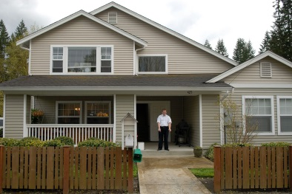
As a result of these moms, and others who joined them, Life Enrichment Options (LEO) was started. This community based non-profit has for 25 years been advocating and supporting individuals with developmental disabilities to achieve their goals through supportive housing, recreation, employment opportunities and community education.

LEO has built and paid for three adult family homes for young adults with disabilities, where they can live independently in a secure and supportive environment.

In addition to the homes, LEO has accomplished a great deal by educating and working to create bridges between the families with disabled children and the non-disabled segments of the community.

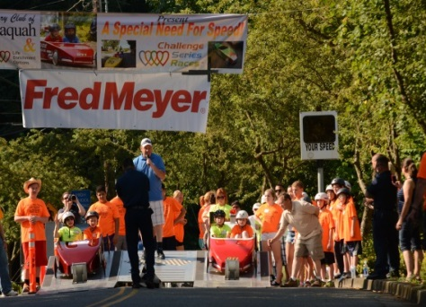
It All Starts With Fun

The parents, who founded LEO, realized that their children needed an activity that they could enjoy, that put them in contact with non-disabled youth and that was fun. An event that is totally planned for their children and is free of charge attracts many families raising children with developmental disabilities as the opportunities are so rare.

History of the Challenge Series Races

The Rotary Club of Oak Harbor was the first in the state to promote a soapbox derby-type of gravity car race for children with developmental disabilities. Using cars originally provided by Puget Power, Oak Harbor staged the first gravity race with a child with developmental disabilities riding in the car next to a non-disabled child who has been trained as a driver. This event has been repeated now for over 20 years and they have touched over 300 families.

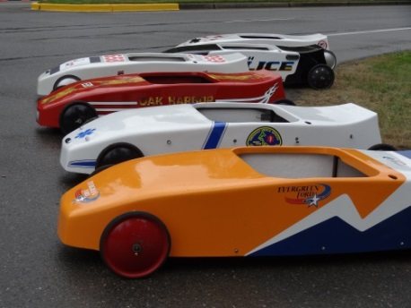
There are now five other Rotary clubs in Issaquah, Sammamish, Snoqualmie and Spokane East hosting an annual Challenge Race. The typical race day starts early, with LEO staff arriving by 7:00 a.m. towing a specially designed trailer holding eight brightly painted racing cars. One car looks like a police vehicle, another like a fire engine complete with red revolving light, while others are decorated by local businesses that help sponsor the races.

The LEO staff and the Rotary members set up the starting ramps and lay out the gently sloping downhill course. Hay bales are placed near curbs and the finish line is set. Local businesses have their ads placed along the course, just like the big-time auto races.

Drivers do a few test races, checking the steering and braking. Soon the local high school teams begin to show up. Cheerleaders line the course and wrestling or football team members volunteer to help at the finish lines. Often bands come to add music to the festivities.
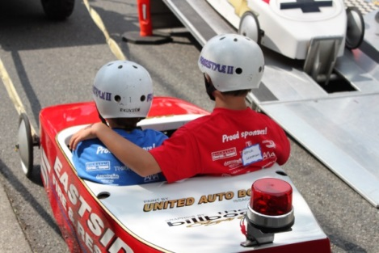
As the children with developmental disabilities arrive, they are welcomed with bright shirts notifying everyone that they are a racer, and here to compete. Drivers are given a shirt with another color, so it is easy to make certain the youth behind the wheel has been trained in all aspects of steering and safety.

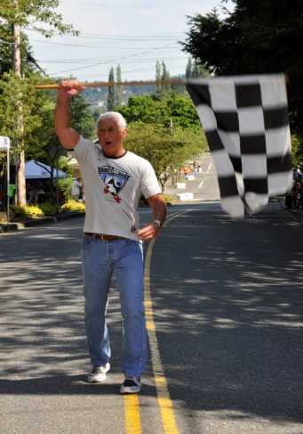
The race cars are positioned on the starting ramp, with Rotarians and community volunteers helping the children wearing the bright shirts into the cars and securing them. The race starters wave the checkered flag to start the races.

The race starters are generally well known people in the community. Members of the state senate and house, the mayor and council members are all honorary race starters.

Soon they are competing as two cars head down the course side-by-side racing each other to the finish line. Once they pass the waving green flag at the finish line, the volunteer students at the bottom congratulate the racers and get the cars turned around so they can be pulled back up the hill; this ATV’s are normally provided by a local business.

Once cars, drivers and riders are returned to the top of the hill past cheering family and community members, another two cars begin their race. During the course of the day, each child with developmental disabilities will race with different drivers and all get numerous races. Due to the ingenuity of those responsible for releasing the cars, everyone is able to come in first at least one time.

The Rotary club also works with local restaurants to cater a lunch for all the participants, parents, volunteers and families. Following lunch is the Awards Ceremony where each child with developmental disabilities has their name announced while coming forward to receive a trophy and a certificate with their name and photo. These are treasured reminders of a day full of fun and friendships.

This is part of a note from a thankful mother of a young girl.

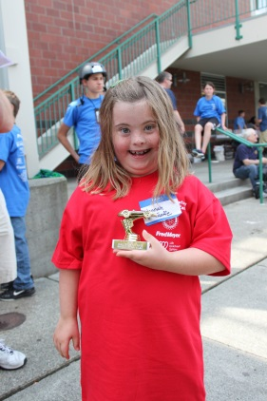
Dear Challenge Series Race Staff:
A thank you note is in order here. Our child had the best time all day. The trophy was a hit. She simply won’t let go of it. It goes to every room with her. Thank you for what you have done for the community of people with children who have disabilities and for their families.

The drivers and passengers are now fully mingling and sharing stories of their races, as the Rotary members and LEO staff pack everything back up into the trailer, clean the course and take the moment to acknowledge that this Challenge Series Race is one of the most meaningful things they do during the entire year.

Laurie is the mother of a driver who had his first involvement with children with developmental disabilities at a Challenge Series Race.

Dear Mr Finnegin:
Just wanted to pass on my thanks again for a great experience for our boys. My son Matthew is still telling his racing tales to his brother and sister, who both want to be drivers next year.

My husband was busy taking pictures today and I wanted to send you my absolute favorite of the day. Love the smile on the child’s face! Hope you enjoy it as well.

See you next year.

Laurie (Pack 684/troop 677)

Secondary Benefits of the Race

The race generates very positive media attention, with both local print and regional TV coverage. This coverage captures the special moments where readers and viewers can see kids with developmental disabilities having fun, interacting with kids their age and seeing the joy on their faces as they come down the race course. This whole experience is interconnected with the sponsoring Rotary Club and the Rotary Wheel.

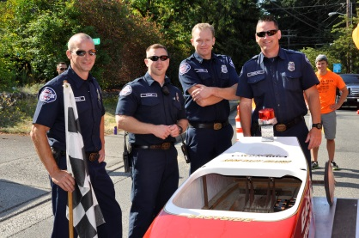
Cooperation from the municipal leaders and staff to give permits, close streets and assign police support, allows their staff and elected officials to begin to see the families with children with developmental disabilities and to acknowledge how many of these families live in their community.

In each of these communities where the races are long-time annual events, there are now young adults who met their first children with developmental disabilities when they were 10-year old drivers. They have grown up remembering those races and friendships and have learned from an early age that although there are differences between them, there is no reason to treat a child with developmental disabilities differently or to ignore them at school.

At each race there are special efforts made to recruit adults with developmental disabilities who are too heavy to be in the race cars. These adults help with the finish line and with the racers.

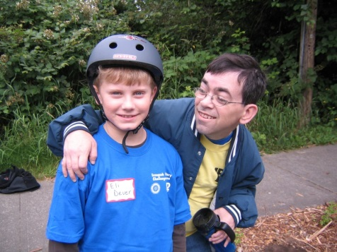
The Rotary Club of Issaquah is presenting their 18th Challenge Series Race on July18th. The Rotary Club of Sammamish has been hosting a race for close to a decade.

An Evolving Partnership

For the local Rotary clubs, hosting a Challenge Race is a Community Service activity structured to raise funds for the club and create a community event that brings a day of joyous fun to children with special needs. “At the end of the day, everyone leaves a winner.”

Organizationally, all of the Challenge Race equipment is supplied by Life Enrichment Options (LEO), a 501 (c) (3) nonprofit in King County. LEO provides instruction on organizing the race, sponsorship activities, recruitment of Drivers and Co-Drivers (the children with special needs).

The partnership between LEO and the local clubs is based on the Four Way test. The funds raised are split evenly between the club and LEO so that it is fair and beneficial to both parties. LEO uses the funds to provide services to people with developmental disabilities in King County. They are currently working to fund a fourth Adult Family homes. These homes are critical to helping the residents have the same sense of security, independence and a place to call home that all parents want for their children. In addition, LEO provides educational classes, employment opportunities and promotes community inclusion for all members.
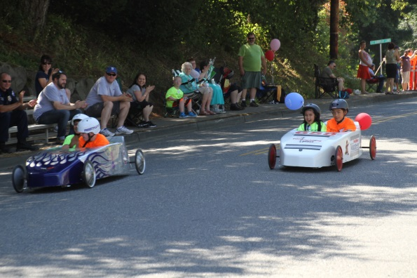
The Rotary clubs in District 5030 are a natural partner to expand the Challenge Series Races into more communities. Every club has members who joined Rotary because they want to give back to their community and to improve the quality of life around them. Most communities have a street on a hill with a 5-7% slope that can be blocked off for half a day as a race course. Every community has children with special needs who desperately want to participate in a fun event where they can be in the “spotlight”. And there is no shortage of typically developing students to volunteer as Drivers and helpers.

Thank you,

Fred Nystrom
Issaquah Rotary Club Past President
Executive Director LEO
425.241.4690

